Physics Internal Assessment

Session: May 2025

The Relationship between the internal pressure and Coefficient of restitution of a Volleyball

Word count: 2983

Table of Contents

1. Research Design 3

1.1 Introduction 3

1.2 Research question 4

1.3 Background information 4

1.4 Hypothesis 6

1.5 Variables 6

1.6 Materials 9

1.7 Methodology 10

1.8 Risk assessment 11

2. Analysis 12

2.1 Data collection 12

2.1.1 Qualitative data 12

2.1.2 Quantitative data 13

2.2 Data Processing 14

2.3 Data Visualization 19

2.4 Data Analysis 21

3. Conclusion 29

4. Evaluation 30

5. Bibliography 33

6. Appendices 35

# 1. Research Design

## 1.1 Introduction

With all the 48[1] Sports in the Olympics there are Factors that can affect the athlete’s performance in their sport for example but not limited to the athletes physical Fitness through training and nutrition, Weather conditions, Event Schedule & Equipment. Those Factors can be classified under two main Categories, modifiable Factors, where athletes have control over it and fixed Factors, where athletes’ influence is limited.

Depending on the Sport, each factor that influences the athlete’s performance is interchangeable under those two categories. For example, in golf, instead of players using a standard golf club, they can customize it to their preferences. In Volleyball, on the other hand, Field Size, Net height, Internal Pressure and Size of the Ball cannot be adjusted to the players' liking but are rather standardized according to the FIVB[2] regulations.

For me, personally was the most exciting factor of all, the Volleyball internal pressure. The Volleyball internal pressure is very important because it changes the elasticity of the Volleyball, which affect its bounce height, rebound height, grip & speed, which are crucial Factors for any Volleyball player.

Hence, I wanted to test and observe the Relation between the internal pressure and the elasticity of a Volleyball at six consecutive bounces.

## 1.2 Research question

How does varying the internal pressure of a Volleyball in the following increments (6.500 psi, 5.500 psi, 4.500 psi, 3.500 psi, 2.500 psi, 2.000 psi) ( 0.001 psi) affect its coefficient of restitution after each bounce throughout six consecutive bounces released from a fixed horizontal displacement of 1.700 m ( m).

## 1.3 Background information

The ball moves through three phases. In the first phase, it starts with gravitational potential energy (GPE), which is converted into kinetic energy (KE) as it falls. In the second phase, upon collision, KE transforms into elastic potential energy (EPE), with some energy lost as heat and sound. In the third phase, the ball rebounds as EPE converts back into KE and then into GPE, but with reduced total energy due to energy losses.

The Coefficient of restitution is the ratio of the velocity components along the normal plane of contact after and before the collision.

Where:

e = coefficient of restitution (Unitless)

vfinal/initial = Velocity of the Object (ms-1)

3 types of elasticity are conducted from the coefficient of restitution, the perfectly inelastic collisions, where the coefficient of restitution equals to 0 & the KE is lost, the perfectly elastic collisions where the coefficient of restitution equals to 1 and no KE is lost, the inelastic collisions, where the coefficient of restitution is between 0 & 1.

The Kinetic and the Gravitational potential energy are connected through this equation according to the law of conservation of energy:

The following equation may be rearranged for the velocity:

Since the coefficient of restitution is based on the velocity at two points, the coefficient of restitution equation could be written as follows:

Hence, the coefficient of restitution is described as the square root of the final height reached by the object divided by the initial height of the object:

Where:

e = coefficient of restitution (Unitless)

hfinal/initial = height of the Object (m)

## 1.4 Hypothesis

Through the information presented in the Background information section it is hypothesized that as the internal pressure of a Volleyball increases, the coefficient of restitution (COR) will also increase until a certain point, where the changes in Pressure will not be as effective on the COR. Thus, the Relationship between the COR and the Pressure is hypothesized to be a non-linear relationship. This hypothesis is supported by the understanding of how pressure affects the elasticity and deformation of the volleyball, which affects its rebound height thus results the COR to be also effected. As mentioned before in the Background information section, that at a certain pressure the ball will resist being deformed, thus result in a loss of less energy. This happens due to the physics of material deformation and the way pressure influences the ball’s behavior during and after impact with the ground.

**NOTE:** This Experiment was conducted assuming that the air resistance is negligible.

## 1.5 Variables

| Manipulated and measured variables | | | |
| --- | --- | --- | --- |
| Variable | | Explanation & Justification | Apparatus |
| Independent variable | Internal Pressure | The Internal Pressure in the volleyball that will be changed as follows: (6.500 psi, 5.500 psi, 4.500 psi, 3.500 psi, 2.500 psi, 1.500 psi)  ( 0.001 psi) ensuring the variety throughout the experiment. | Volleyball pump with a Pressure gauge ( 0.001 psi) based on the smallest increment in the analog instrument and human error in readings) |
| Dependent variable | Coefficient of restitution | The Rebound height of the volleyball over six consecutive bounces is being used to calculate the coefficient of restitution | Video analysis software “Tracker”  ( 0.020 due to the precision of the video analysis software). |

Table 1: Independent and dependent Variable

The range of values were chosen to have values above the standard game pressure (4.3-4.6 psi) and below the standard game pressure to provide an insight on how the COR changes throughout the variations. Choosing a higher Pressure than the maximum (6.500 0.001 psi) will result in the balls inconsistency and a potential risk of structural deformation. Choosing Pressures lower than (1.500 0.001 psi) will result in the ball not completing the 6 bounces, hence not complying with the other pressure variations.

| Controlled Variables | | |
| --- | --- | --- |
| Variable | Significance | Methods of control |
| Type of Volleyball | The material/surface of  the volleyball affects its elasticity and reaction with the surface as well. | Using the same volleyball for all trials. |
| Drop height | Ensures consistent GPE and KE for each trial, which affects the volleyball’s rebound height. | Releasing the ball from a fixed height throughout the trials. (1.700 0.001 m due to error in measurements). |
| Surface of impact | Inconsistency on the surface could affect the energy loss during each collision. | Conducting the experiment on concrete, a flat and hard surface across all trials. |
| Temperature | The elasticity of a material depends on the Temperature. | Conducting the trials in an indoor environment where the humidity & temperature difference is minimized across all trials.  (T = 22.000 °C 0.010 °C)  (Uncertainty due to the smallest detection of the thermometer used to measure the room temperature). |
| Humidity | Humidity affects the material’s properties which changes its elasticity. |
| Air composition | The change in the type of gas used affects its elasticity and pressure. | Inflating the Volleyball with standard air composition across trials.  (≈ 78% nitrogen,  ≈ 21% oxygen) |
| Bounce sequence timing | Interruption between bounces could affect measurements due to the volleyball’s reforming into original shape. | Allowing Volleyball to complete all bounces in one trial. |

Table 2: Controlled Variables

|  |  |
| --- | --- |
| Uncontrolled Variables | |
| Variable | **Significance** |
| Environmental factors | Minor air current changes, vibrations & external noise can affect volleyball’s rebound height. |
| Material aging | Repeated trials slightly change Volleyball’s elasticity, which impacts the results over time. |
| Surface imperfections | Uneven surfaces could cause slight deviations in rebound height. |

Table 3: Uncontrolled Variables

## 1.6 Materials

1. Mikasa V330W Volleyball (Diameter 20.700 - 21.300 cm)
2. Pressure Gauge ( 0.001 psi)
3. Electric / Manual air pump
4. 1 meter of Sewing Measuring tape ( 0.005 meter (based on half the smallest increment))
5. Paper
6. Marker
7. Scissors
8. Smartphone or Camera
9. Tripod
10. Tape
11. Flat, Hard Surface
12. Video analysis software “Tracker”[3]
13. Laptop

## 1.7 Methodology

1. 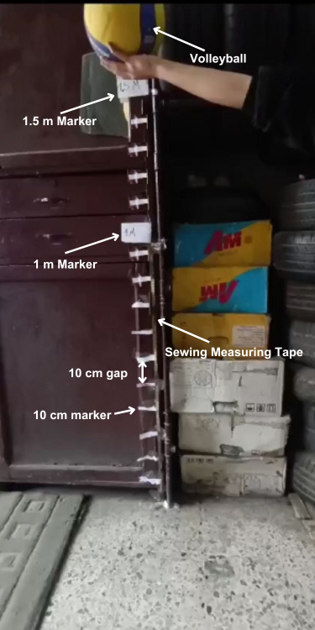Attach the Sewing measuring tape vertically against a flat wall with the tape.
2. Cut the Paper into two big pieces.
3. Mark the Papers with 1.000- & 1.700-meter with the marker
4. Attach the markers to the wall with the height of the marker.
5. Cut another paper into fifteen slim pieces.
6. Attach the fifteen slim pieces to the wall with a 10.000 cm gap.
7. Inflate the Volleyball fully.
8. Connect the Volleyball to the pressure gauge and adjust the internal pressure to the required level
9. Setup the smartphone on the tripod perpendicular to the wall

Figure 1: Image of the Experiment (Image self-taken and self-labelled using canva)

1. Setup the smartphone into Video mode
2. Release the Volleyball from the 1.7-meter mark (measured from the bottom of the ball) and start recording the first 6 consecutive bounces.
3. Insert the Videos into “Tracker”
4. Add & adjust the Coordinate axes to align with the floor and the wall from the tool’s menu.
5. Add a 1.7-meter calibration stick from the menu and adjust it with the Coordinate axes, the floor, and the wall.
6. Track the Volleyball through each frame and the data will be shown automatically to the right of the screen through a table and an x & y-coordinate.
7. 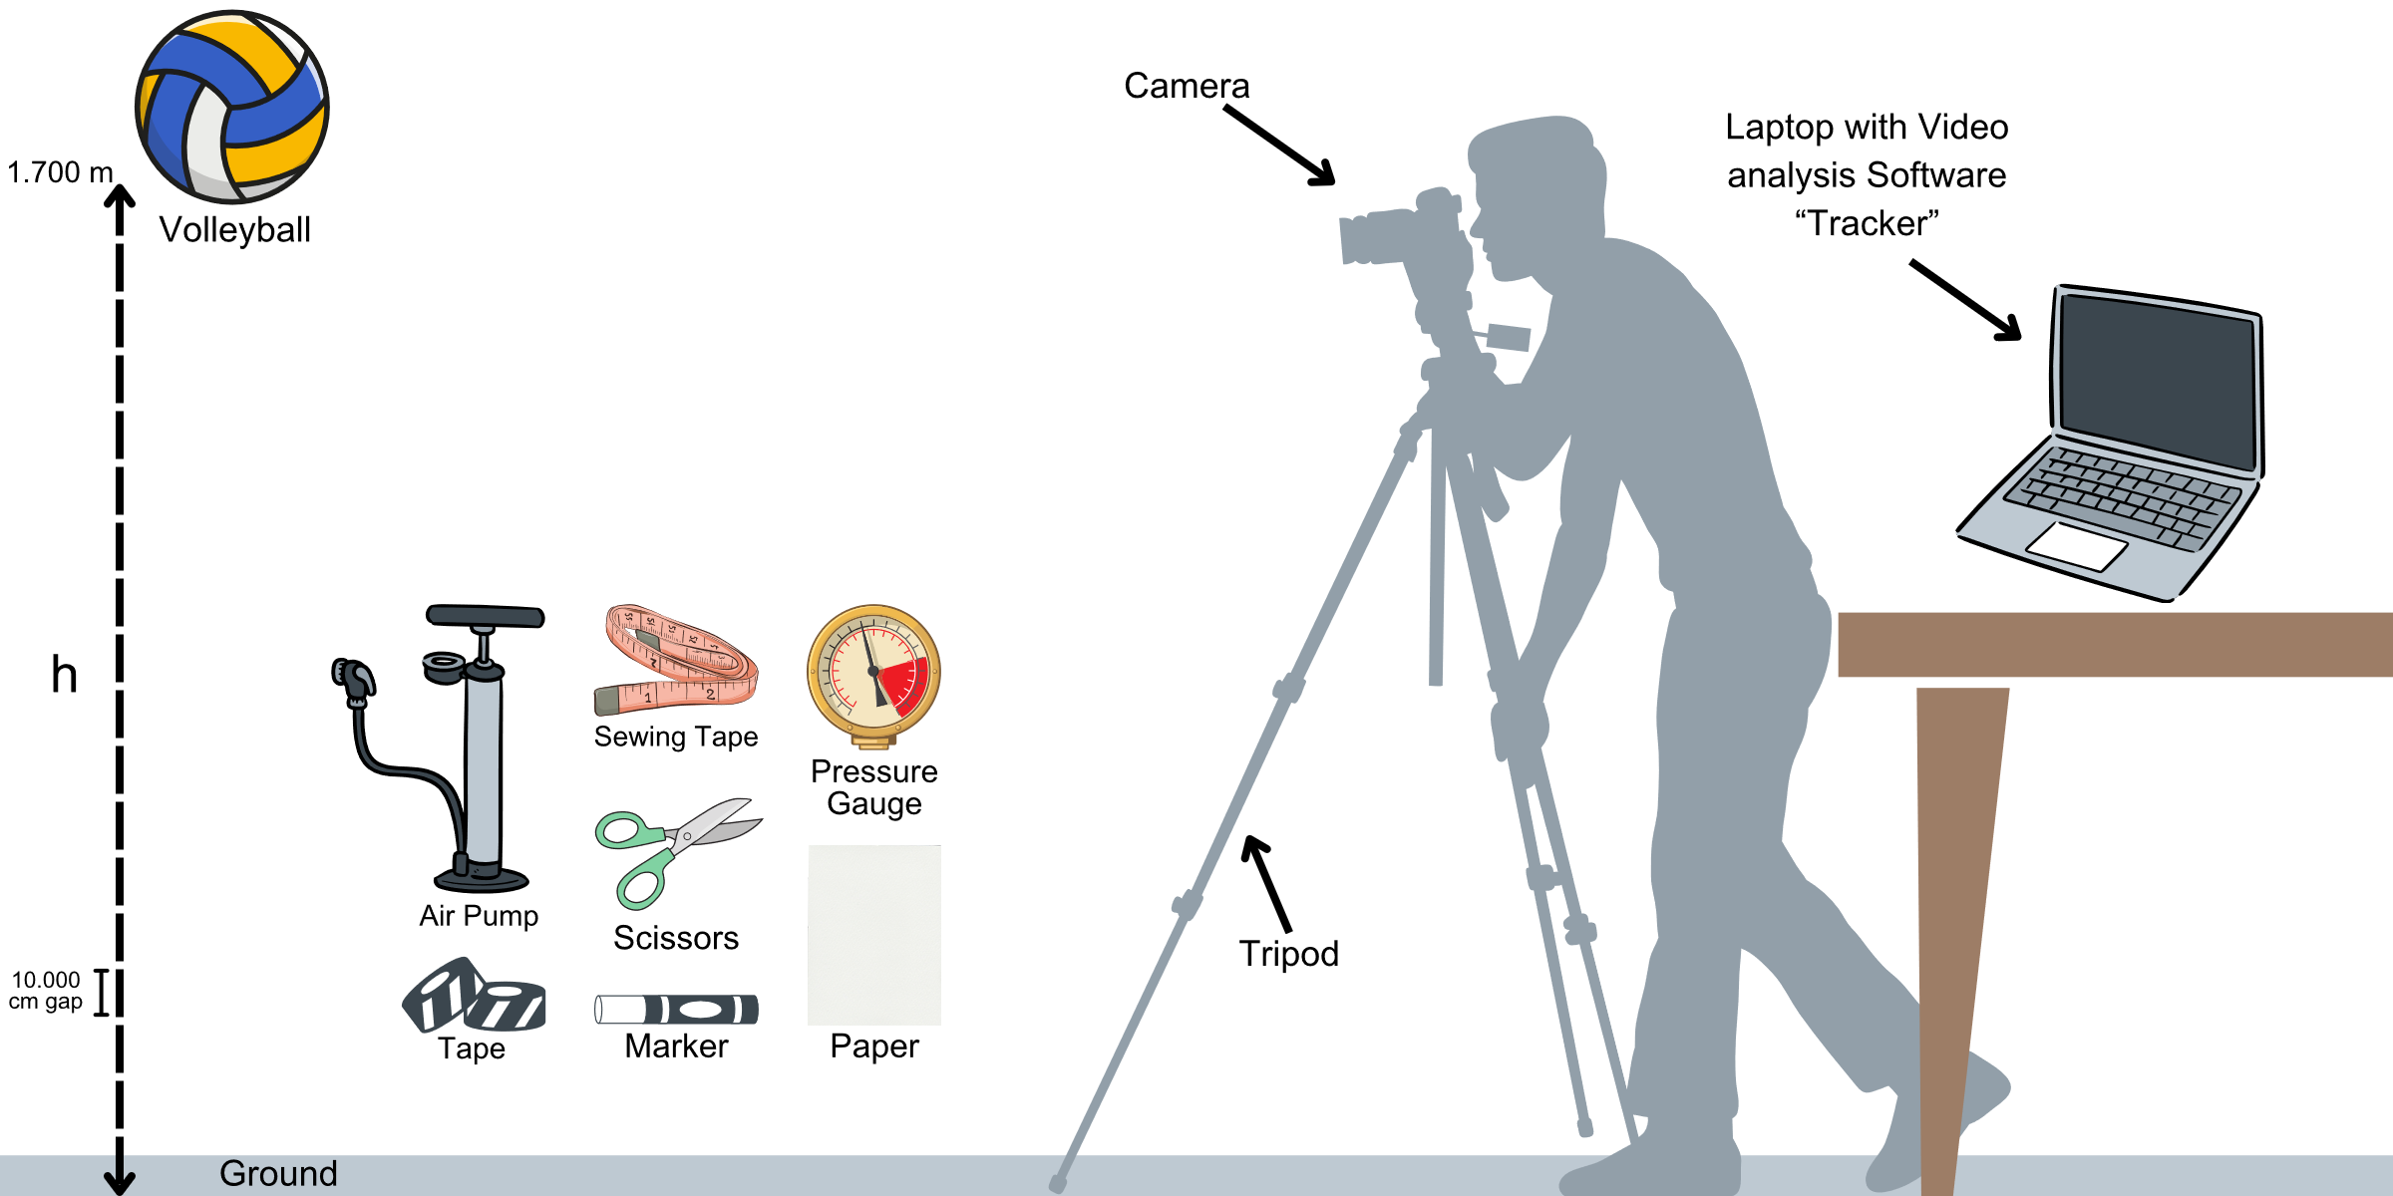Repeat Point 7-15 for the 6 different pressures and for 5 trials.

Figure 2: Experimental setup with tools used (self-designed using Canva)

## 1.8 Risk assessment

|  |  |
| --- | --- |
| Consideration Type | Significance |
| Safety Considerations | Safety considerations were taken through ensuring the volleyball is inflated to a safe pressure range to prevent over-inflation and the volleyball’s burst, which will increase the risk of injury from the flying fragments.  Handling also the air pump carefully to avoid any release of air that could cause an injury. |
| Ethical Considerations | The experiment does not involve ethical considerations as there was no animal use and the data was not collected from human participants. |
| Environmental Considerations | While pumping Volleyball there were single-use pumps and gloves used to reduce waste and promote sustainability.  After the experiment, Volleyball was donated to a refugee camp for free to reduce waste by repurposing volleyball as sports equipment for the children. This minimizes the environmental impact. |

Table 4: Risk assessment

# 2. Analysis

## 2.1 Data collection

### 2.1.1 Qualitative data

The results were plotted using the video analysis software “Tracker”.

Figure 3: Data analysis (graph obtained using "Tracker") for trial 1 (5.500 PSI)

The graph shows the maximum height achieved of the Volleyball through six consecutive bounces. At the start of the graph the initial height of the Volleyball is pointed out (1.700 meters). The height of the volleyball decreases until hitting the ground. The Volleyball then goes upwards and reaches a new height which is the final height of the ball after the first bounce. This reaction is repeated until the ball reaches the sixth consecutive bounce or goes to rest.

### 2.1.2 Quantitative data

|  |  |  |  |  |  |  |  |
| --- | --- | --- | --- | --- | --- | --- | --- |
| Pressure in PSI ( PSI) | Trial | Bounce 1 in m () | Bounce 2 in m () | Bounce 3 in m () | Bounce 4 in m () | Bounce 5 in m () | Bounce 6 in m () |
| 6.500 | 1 | 1.520 | 1.320 | 1.140 | 0.980 | 0.830 | 0.700 |
| 2 | 1.500 | 1.300 | 1.120 | 0.960 | 0.820 | 0.680 |
| 3 | 1.490 | 1.290 | 1.110 | 0.950 | 0.810 | 0.670 |
| 4 | 1.530 | 1.330 | 1.150 | 0.990 | 0.840 | 0.710 |
| 5 | 1.510 | 1.310 | 1.130 | 0.970 | 0.830 | 0.690 |
| 5.500 | 1 | 1.430 | 1.240 | 1.070 | 0.920 | 0.780 | 0.650 |
| 2 | 1.410 | 1.220 | 1.050 | 0.900 | 0.760 | 0.630 |
| 3 | 1.420 | 1.230 | 1.060 | 0.910 | 0.770 | 0.640 |
| 4 | 1.440 | 1.250 | 1.080 | 0.930 | 0.790 | 0.660 |
| 5 | 1.420 | 1.230 | 1.060 | 0.910 | 0.770 | 0.640 |
| 4.500 | 1 | 1.320 | 1.140 | 0.980 | 0.840 | 0.710 | 0.590 |
| 2 | 1.300 | 1.120 | 0.960 | 0.820 | 0.690 | 0.570 |
| 3 | 1.310 | 1.130 | 0.970 | 0.830 | 0.700 | 0.580 |
| 4 | 1.330 | 1.150 | 0.990 | 0.850 | 0.720 | 0.600 |
| 5 | 1.310 | 1.130 | 0.970 | 0.830 | 0.700 | 0.580 |
| 3.500 | 1 | 1.180 | 1.020 | 0.870 | 0.740 | 0.620 | 0.510 |
| 2 | 1.160 | 1.000 | 0.850 | 0.720 | 0.600 | 0.490 |
| 3 | 1.170 | 1.010 | 0.860 | 0.730 | 0.610 | 0.500 |
| 4 | 1.190 | 1.030 | 0.880 | 0.750 | 0.630 | 0.520 |
| 5 | 1.170 | 1.010 | 0.860 | 0.730 | 0.610 | 0.500 |
| 2.500 | 1 | 1.000 | 0.860 | 0.730 | 0.620 | 0.520 | 0.430 |
| 2 | 0.980 | 0.840 | 0.710 | 0.600 | 0.500 | 0.410 |
| 3 | 0.990 | 0.850 | 0.720 | 0.610 | 0.510 | 0.420 |
| 4 | 1.010 | 0.870 | 0.740 | 0.630 | 0.530 | 0.440 |
| 5 | 0.990 | 0.850 | 0.720 | 0.610 | 0.510 | 0.420 |
| 1.500 | 1 | 0.810 | 0.700 | 0.590 | 0.500 | 0.420 | 0.350 |
| 2 | 0.790 | 0.680 | 0.580 | 0.490 | 0.410 | 0.340 |
| 3 | 0.800 | 0.690 | 0.590 | 0.500 | 0.420 | 0.340 |
| 4 | 0.820 | 0.710 | 0.600 | 0.510 | 0.430 | 0.360 |
| 5 | 0.800 | 0.690 | 0.580 | 0.490 | 0.410 | 0.340 |

Table 5: Raw data tables of the Experiment in Six different pressures through 5 Trials

The uncertainty used in the Pressure columns are according to the pressure gauges smallest increment, which states that the uncertainty is = 0.001PSI.

The uncertainty used in the rebound height column is according to the human reading error of the height in “Tracker” the video analysis software.

## 2.2 Data Processing

The data acquired by the experiment was first processed by calculating the mean maximum height of each bounce through the 5 trials in the 6 different pressures. The mean maximum height was calculated through the sum of trial values divided by the number of trials which are 5 in each bounce.

Where:

= the average height (meter)

= the height in the -th trial (meter)

= number of trials (in this experiment = 5)

The average height of each bounce in each pressure will then be calculated into the derived formula acquired from the background information section of the Coefficient of restitution.

For bounce 1:

For Bounces from 2 to 6:

Where:

= =

= =

Thus, this general formula is acquired for all Bounces.

|  |  |
| --- | --- |
| **Processed Data** | **Example:** |
| |  |  |  |  |  |  |  | | --- | --- | --- | --- | --- | --- | --- | | Pressure (PSI) () | Bounce 1 in m | Bounce 2 in m | Bounce 3 in m | Bounce 4 in m | Bounce 5 in m | Bounce 6 in m | | 6.500 | 1.510 | 1.310 | 1.130 | 0.970 | 0.826 | 0.690 | | 5.500 | 1.424 | 1.234 | 1.064 | 0.914 | 0.774 | 0.644 | | 4.500 | 1.314 | 1.134 | 0.974 | 0.834 | 0.704 | 0.584 | | 3.500 | 1.174 | 1.014 | 0.864 | 0.734 | 0.614 | 0.504 | | 2.500 | 0.994 | 0.854 | 0.724 | 0.614 | 0.514 | 0.424 | | 1.500 | 0.804 | 0.694 | 0.588 | 0.498 | 0.418 | 0.346 |   Table 6: Processed mean height at Six different pressures through 5 Trials | Calculating Bounce 1 Pressure 5.500 0.001 psi using equation 7: |
| |  |  |  |  |  |  |  | | --- | --- | --- | --- | --- | --- | --- | | Absolute Uncertainty | | | | | | | | Pressure (PSI) () | **Bounce 1** in m | **Bounce 2** in m | **Bounce 3** in m | **Bounce 4** in m | **Bounce 5** in m | **Bounce 6** in m | | 6.500 | 0.020 | 0.020 | 0.020 | 0.020 | 0.015 | 0.020 | | 5.500 | 0.015 | 0.015 | 0.015 | 0.015 | 0.015 | 0.015 | | 4.500 | 0.015 | 0.015 | 0.015 | 0.015 | 0.015 | 0.015 | | 3.500 | 0.015 | 0.015 | 0.015 | 0.015 | 0.015 | 0.015 | | 2.500 | 0.015 | 0.015 | 0.015 | 0.015 | 0.015 | 0.015 | | 1.500 | 0.015 | 0.015 | 0.010 | 0.010 | 0.010 | 0.010 |   Table 7: Processed mean height Absolute Uncertainty | Calculating Bounce 1 Pressure 6.500 psi using equation 12: |
| |  |  |  |  |  |  |  | | --- | --- | --- | --- | --- | --- | --- | | Fractional Uncertainty | | | | | | | | Pressure (PSI) () | **Bounce 1** in m | **Bounce 2** in m | **Bounce 3** in m | **Bounce 4** in m | **Bounce 5** in m | **Bounce 6** in m | | 6.500 | 0.013 | 0.015 | 0.018 | 0.021 | 0.018 | 0.029 | | 5.500 | 0.011 | 0.012 | 0.014 | 0.016 | 0.019 | 0.023 | | 4.500 | 0.011 | 0.013 | 0.015 | 0.018 | 0.021 | 0.026 | | 3.500 | 0.013 | 0.015 | 0.017 | 0.020 | 0.024 | 0.030 | | 2.500 | 0.015 | 0.018 | 0.021 | 0.024 | 0.029 | 0.035 | | 1.500 | 0.019 | 0.022 | 0.017 | 0.020 | 0.024 | 0.029 |   Table 8: Processed mean height Fractional Uncertainty | Calculating Bounce 3 Pressure 3.500 psi using equation 13: |

Second, by processing the data, the rebound height’s absolute uncertainty is calculated by subtracting the maximum height value with the minimum height value of the desired bounce & pressure and dividing it by 2.

where:

= Rebound height’s absolute uncertainty (Unitless)

= height (m)

Third, the Fractional/Relative uncertainty of the rebound height is based on its absolute uncertainty where the fractional uncertainty is the absolute uncertainty divided by the magnitude of the quantity.

In the calculations of the absolute and fractional uncertainty of the Coefficient of restitution the operation is more complicated, where the fractional uncertainty in the Coefficient of restitution is derived using the propagation of uncertainties for a square root[4].

Substituting into the propagation of uncertainties as follows:

Where:

= Fractional uncertainty of the coefficient of restitution (Unitless)

By multiplying the Fractional uncertainty with the coefficient of restitution the absolute uncertainty of the coefficient of restitution is acquired.

|  |  |
| --- | --- |
| **Processed Data** | **Example:** |
| |  |  |  |  |  |  |  | | --- | --- | --- | --- | --- | --- | --- | | Pressure (PSI) () | Bounce 0-1 | Bounce 1-2 | Bounce 2-3 | Bounce 3-4 | Bounce 4-5 | Bounce 5-6 | | 6.500 | 0.942 | 0.931 | 0.929 | 0.926 | 0.923 | 0.914 | | 5.500 | 0.915 | 0.931 | 0.929 | 0.927 | 0.920 | 0.912 | | 4.500 | 0.879 | 0.929 | 0.927 | 0.925 | 0.919 | 0.911 | | 3.500 | 0.831 | 0.929 | 0.923 | 0.922 | 0.915 | 0.906 | | 2.500 | 0.765 | 0.927 | 0.921 | 0.921 | 0.915 | 0.908 | | 1.500 | 0.688 | 0.929 | 0.920 | 0.920 | 0.916 | 0.910 |   Table 9: Processed COR at Six different pressures through 5 Trials | Calculating Bounce 0-1 Pressure 6.500 0.001 psi using equation 7: |
| |  |  |  |  |  |  |  | | --- | --- | --- | --- | --- | --- | --- | | Absolute Uncertainty | | | | | | | | Pressure (PSI) () | **Bounce 0-1** | **Bounce 1-2** | **Bounce 2-3** | **Bounce 3-4** | **Bounce 4-5** | **Bounce 5-6** | | 6.500 | 0.012 | 0.013 | 0.015 | 0.018 | 0.018 | 0.022 | | 5.500 | 0.010 | 0.011 | 0.012 | 0.014 | 0.016 | 0.019 | | 4.500 | 0.010 | 0.011 | 0.013 | 0.015 | 0.018 | 0.021 | | 3.500 | 0.010 | 0.013 | 0.015 | 0.017 | 0.021 | 0.025 | | 2.500 | 0.010 | 0.015 | 0.018 | 0.021 | 0.025 | 0.029 | | 1.500 | 0.010 | 0.019 | 0.018 | 0.017 | 0.020 | 0.024 |   Table 10: Processed COR Absolute Uncertainty | Calculating Bounce 3 Pressure 4.500 psi using equation 12: |
| |  |  |  |  |  |  |  | | --- | --- | --- | --- | --- | --- | --- | | Fractional Uncertainty | | | | | | | | Pressure (PSI) () | **Bounce 0-1** | **Bounce 1-2** | **Bounce 2-3** | **Bounce 3-4** | **Bounce 4-5** | **Bounce 5-6** | | 6.500 | 0.013 | 0.014 | 0.016 | 0.019 | 0.019 | 0.024 | | 5.500 | 0.011 | 0.011 | 0.013 | 0.015 | 0.018 | 0.021 | | 4.500 | 0.012 | 0.012 | 0.014 | 0.017 | 0.020 | 0.023 | | 3.500 | 0.012 | 0.014 | 0.016 | 0.019 | 0.022 | 0.027 | | 2.500 | 0.013 | 0.016 | 0.019 | 0.023 | 0.027 | 0.032 | | 1.500 | 0.015 | 0.020 | 0.019 | 0.019 | 0.022 | 0.026 |   Table 11: Processed COR Fractional Uncertainty | Calculating Bounce 3 Pressure 3.500 psi using equation 14: |

**NOTE:** COR is Unitless

## 2.3 Data Visualization

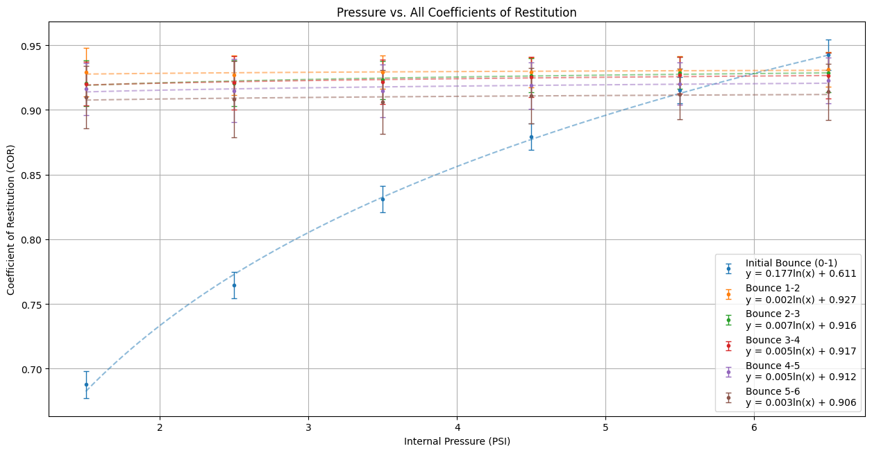

Graph 1: Data Visualization of the Coefficient of Restitution and its relationship with the Internal Pressure within 6 consecutive bounces (self-coded using python libraries matplotlib, numpy & pandas) (Appendices)

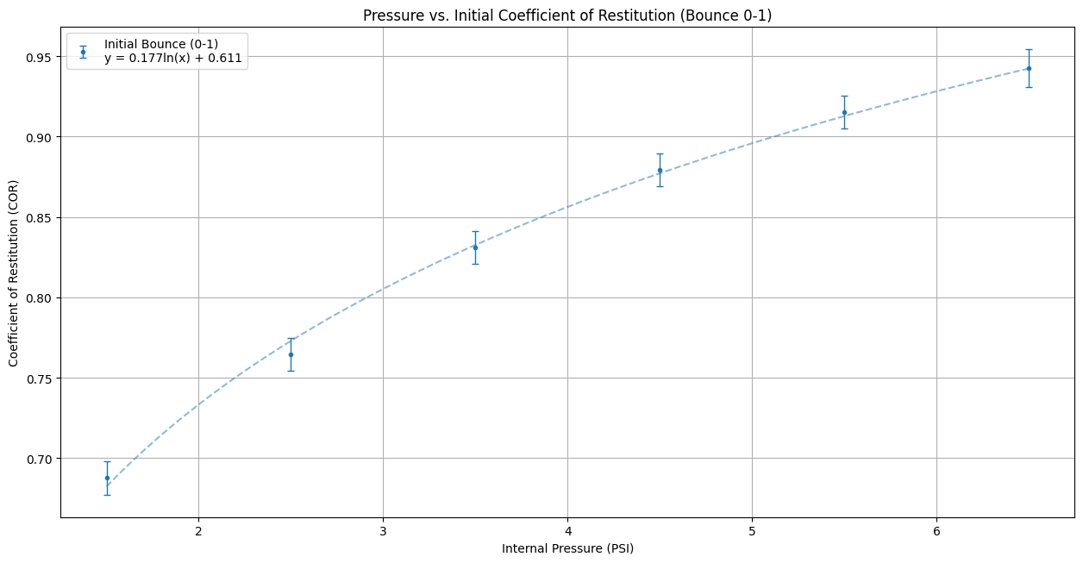

Graph 1.1: Data Visualization of the Coefficient of Restitution and its relationship with the Internal Pressure within bounces 0-1 (self-coded using python libraries matplotlib, numpy & pandas) (Appendices)

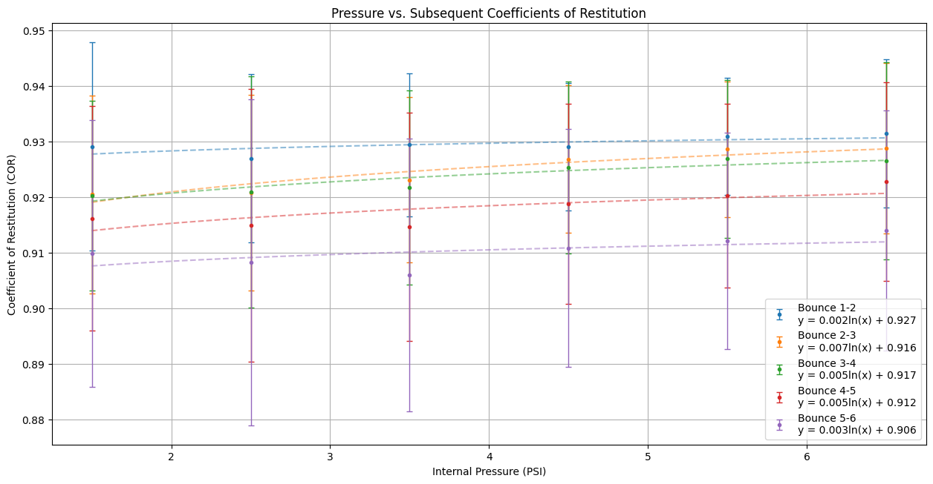

Graph 1.2: Data Visualization of the Coefficient of Restitution and its relationship with the Internal Pressure bounces 1-6 (self-coded using python libraries matplotlib, numpy & pandas) (Appendices)

**NOTE:** Due to viewing the Internal Pressure in the x-axis in 1 step, the uncertainty of the Internal Pressure conducted ( psi)is not observed.

## 2.4 Data Analysis

From the Data acquired from the Calculation of the Coefficient of restitution in table 9 and plotting it against the Internal Pressure of the Volleyball in Graph 1 is observed, that throughout the Bounces from 1-6 there is no significant change that could be taken into account. Taking the fact that the Data between the Coefficient of Restitution and Internal Pressure from Bounce 1-6 forms roughly a linear Relationship that remains approximately constant compared to the Data between Bounces 0-1, where there is a significant change in the Relationship between the COR and the Internal Pressure forming a logarithmic function. This is further explained in the Conclusion & Evaluation Section.

Due to the change in Behavior of the Relationship between the COR and the Pressure, to proceed in the Data analysis the mean COR across the six bounces will be taken as follows:

Where:

= The mean COR

= Individual COR values for each bounce

Then calculating the Fractional and Absolute Uncertainty through both equations:

|  |  |
| --- | --- |
| Using the Standard Error of the Mean equation (SEM) this equation for the standard deviation is derived:  When inserting the derived standard deviation equation into the (SEM) Equation; is the Absolute uncertainty of the Mean COR acquired: | By dividing the Absolute uncertainty with the mean coefficient of restitution the fractional uncertainty of the mean coefficient of restitution is acquired. |

Where:

= Mean COR’s fractional Uncertainty across six bounces

= Mean COR’s absolute Uncertainty across six bounces

|  |  |
| --- | --- |
| Processed Data | Examples |
| |  |  |  |  |  | | --- | --- | --- | --- | --- | | Pressure (PSI)  (PSI) | Mean COR | Standard Deviation () | Absolute Uncertainty | Fractional Uncertainty | | 6.500 | 0.927 | 0.009 | 0.003 | 0.004 | | 5.500 | 0.922 | 0.007 | 0.003 | 0.003 | | 4.500 | 0.915 | 0.018 | 0.007 | 0.008 | | 3.500 | 0.904 | 0.036 | 0.015 | 0.016 | | 2.500 | 0.892 | 0.063 | 0.025 | 0.028 | | 1.500 | 0.880 | 0.094 | 0.038 | 0.043 |   Table 12: Processed mean COR with Standard deviation, Absolute & Fractional Uncertainty | Calculating Mean COR Pressure 3.500  0.001 psi using equation 16: |
| Calculating Standard Deviation Pressure 3.500 0.001 psi using equation 17: |
| Calculating Absolute Uncertainty Pressure 3.500 0.001 psi using equation 18: |
| Calculating Fractional Uncertainty Pressure 3.500 0.001 psi using equation 20: |

**NOTE:** Here the SEM equations were used instead of equations 14 and 15 in calculating the uncertainties due to the equations used above being good for individual COR calculations not for calculating the uncertainty of the mean COR across multiple Pressures. This results in a more precise estimate of the mean COR.

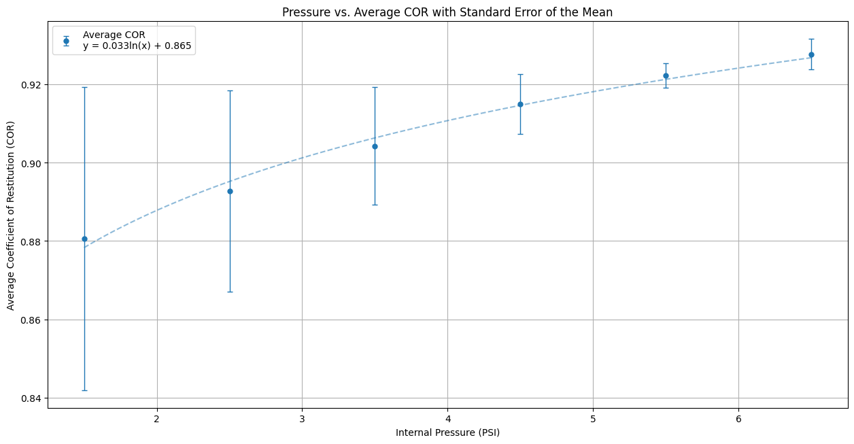

Graph 2: Data Visualization of the Mean Coefficient of Restitution and its relationship with the Internal Pressure bounces 1-6 (self-coded using python libraries matplotlib, numpy & pandas) (Appendices)

In Graph 2 it is observed that the Relationship between the COR and the Internal Pressure of the Volleyball is a logarithmic relationship, which furthermore supports my stated hypothesis.

For the function to be linear, the linear trendline must go through all Error bars, which does not happen here. This Indicates that the Relationship between the COR and the Internal Pressure of the Volleyball is not in fact a linear relationship. This supports my stated hypothesis. The logarithmic trendline fits the data points almost perfectly according to the coefficient of determination , which calculates how well the data fits a regression model. The Calculation of in the logarithmic was done by a self-programmed code using python (Appendices).



Figure 4: The Results of the calculated value of for the best-fit logarithmic equation in Graph 2 (self-coded using python library numpy) (Appendices)

The presented value of 0.989 shows that the logarithmic trendline fits the data points near perfectly with a 98.930% accuracy. This furthermore supports the stated hypothesis.

To learn more about the relationship between the COR and the Internal Pressure of the Volleyball the gradient of the logarithmic equation acquired from graph 2 will be obtained through calculating the first derivative of the logarithmic equation:

Where:

= gradient

= Pressure (PSI)

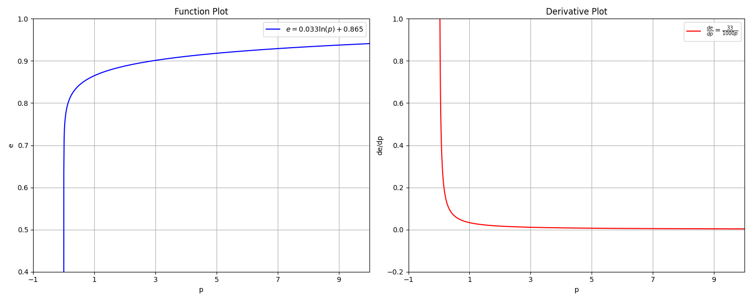

Graphs 4 & 5: Data Visualization of the logarithmic equation in Graph 2 against its derivative (self-coded using python libraries matplotlib & numpy) (Appendices)

The Gradient calculated and observed in Graph 5 forms a rational function. The rational function shows that the gradient follows a hyperbolic decay pattern, meaning that at small values of 𝑝, the gradient is large, thus function 𝑒(𝑝) in Graph 4 increases rapidly. As 𝑝 increases in Graph 5, the gradient decreases, hence function 𝑒(𝑝) in Graph 4 growth rate slows down. This slowing down keeps happening as 𝑝 tends to infinity, which results the derivative in graph 5 to approach an asymptote at the x-axis. This furthermore supports the hypothesis presented above, where after certain 𝑝 values the COR keeps increasing but at a decreasing rate. In Graph 5 is also observed that the volleyball’s pressure cannot be 0 or negative that is why there is a vertical formed at 𝑥=0. Also, according to Graph 4 energy dissipates always from the volleyball as function 𝑒(𝑝) never decreases. This indicates that the energy dissipates even when the COR and Pressure keep rising, which furthermore aligns with the hypothesis presented above and the principles of energy loss in an inelastic system. Additionally, since the gradient in graph 5 remains positive for all valid 𝑝 values, it confirms that 𝑒(𝑝) is strictly increasing, hence no pressure value leads the COR to decrease throughout the investigated range.

To furthermore explain the relationship between the COR and Pressure, linearizing the equation obtained from Graph 2 is vital through inserting the values into the Slope-intercept form of linear equations:

Where:

= Slope

= y-intercept

=

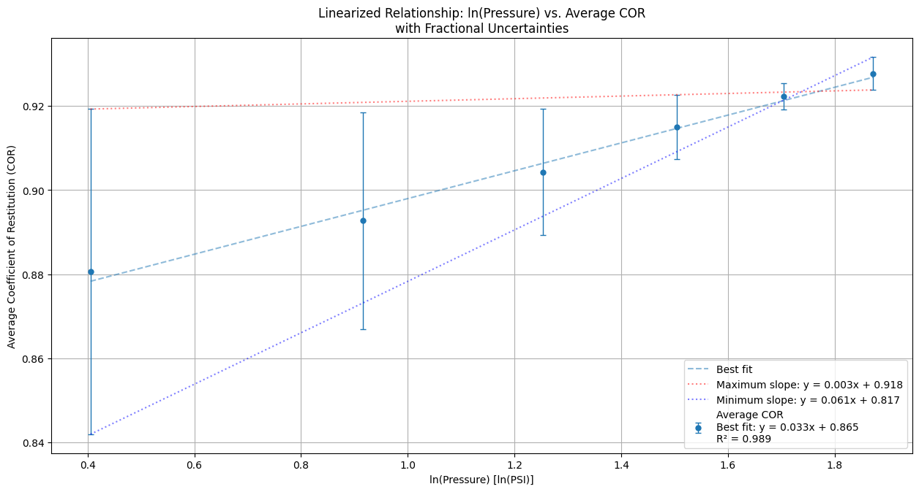

Graphs 6: Data Visualization of the linearized logarithmic equation 24 with its maximum and minimum slope varients(self-coded using python libraries matplotlib, numpy & pandas) (Appendices)

Rearranging equation 24 to make the gradient the subject will result in:

Hence, equation 31 shows that there is a positive linear relationship between and the COR. This is supported by Graph 6’s best-fit line, where its = 0.989 or 98.9% which furthermore supports the hypothesis mentioned before. However, the maximum and minimum slope within the error bars indicate that there could be other variations to the Slope and y-intercept in-between them.

The Absolute Uncertainty of the gradient is calculated as follows:

The Fractional Uncertainty of the Gradient is calculated as follows:

or

Fractional Uncertainty is extensively high relative to the magnitude of the gradient. This suggests that the measurements are not very precise, as the Absolute uncertainty of the gradient being almost as large as the gradient. This will be discussed in the Evaluation section extendedly.

The p-value determines the relationship between the independent and the dependent variable. The p-value of the function was calculated using acquired from Graph 6. The p-value was calculated through self-programmed code using python (Appendices).

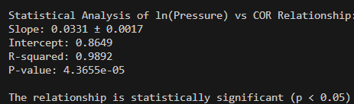

Figure 5: The Results of the calculated value of for the best-fit logarithmic equation in Graph 6 (self-coded using python libraries numpy & scipy) (Appendices)

As the code states, the p-value for the linearized equation is . This is a strong indication that the relationship between Pressure and the COR is statistically significant, since the p-value is less than common significance threshold .

# 3. Conclusion

My Research question “How does varying the internal pressure of a Volleyball in the following increments (6.500 psi, 5.500 psi, 4.500 psi, 3.500 psi, 2.500 psi, 1.500 psi) ( 0.001 psi) affect its coefficient of restitution after each bounce throughout six consecutive bounces released from a fixed horizontal displacement of (1.700 m).” aims to investigate the relationship between pressure and the COR.

With the support of the physical principles of Pressure and the COR presented in the Background information section was hypothesized, that the Relationship between the Pressure inside a Volleyball and its COR is an increasing relationship at a decreasing rate, which was extensively proven throughout the Data analysis Section specifically through Graph 5. The Raw data for the initial and final height were taken from table 5 and processed through the derived equation of the COR. Plotting the Processed data in Graph 1 for the COR against the Pressure showed the difference in the COR’s behavior between the first Bounce of the Ball and the Bounces from 2-6.

The change in Behavior of the COR throughout the bounces occurred because of the relatively big difference between the initial height ( and the first Bounce's rebound height or final height, which varies between ) and ( throughout different Pressures (table 9). That makes the difference seen in the first Column of the data in table 9 where the lowest COR calculation is (0.687 ), that occurs at height ) and the highest COR calculation is (0.942 at height (. On the other hand, in Graph 1.2 is observed that by calculating the COR of the Second to the 6th bounce, the difference between the initial height the ball was released from – which is in practice the final height of the bounce preceding as observed through the general equation presented in the data processing section (equation 10), and the final height is relatively smaller than the difference between Bounce 0-1. This resulted in the Graph 1 the Bounces from 2-6 to appear as a constant, which is right relative to the first Bounce but wrong relative to each other, as observed in Graph 1.2.

This change in Behavior is the results of the Pressure variations being too narrow to each other, which is limited by the Volleyball’s material. This is further explained in the Evaluation section.

Furthermore, the p-value resulting in such a small number (Figure 5) indicates that the observed variations in the COR of the volleyball are unlikely to be due to random chance alone and internal Pressure plays a significant role in determining the rebound height of the ball, hence its COR. The small p-value supports also the validity of the linearized model in describing the relationship between pressure and COR.

# 4. Evaluation

## 4.1 Uncertainty

The ranges of the magnitudes of the COR calculated from individual trials varied greatly for different pressure data points across 6 bounces. The smallest range of was recorded at pressure 5.5 PSI PSI), while the largest range of was recorded at pressure 1.5 PSI PSI). This variation happens because of lower pressures introducing more inconsistencies across 6 Bounces. On the other hand, in high pressures there is a more predictable way of the ball behaving,

thus reduces measurement variability.

These uncertainties do in fact originate from both random and systematic errors. However, their overall consistency suggests that the experimental setup was well-controlled. Yet, minor errors such as inconsistencies in the Volleyball's landing orientation, the ball not bouncing perfectly vertical and making horizontal displacement while falling could have influenced the results. These potential sources of error align with the patterns observed in the raw data in table 5 and processed data of the COR in (table 9).

## 4.2 Comparison

According to a research conducted on the same topic, a logarithmic relationship between the COR and the Pressure was found indicating that as pressure increases, the COR increases at a decreasing rate (K. Osman and B.S. Kim, 2009). This is supported by the physical characteristics of pressure. Hile higher pressure enhances the ball’s ability to retain and transfer kinetic energy, this effect diminishes after a certain point, leading to the decay pattern. This matches the hypothesis mentioned before.

## 4.3 Strength

|  |  |
| --- | --- |
| Strength | Discussion |
| Preliminary trials | Taking initial tests helped identify any potential sources of error such as not using Pressures less than 1.500 psi because it results into the Volleyball not going through all 6 bounces. |
| Data Calculated computationally | To ensure precision and minimize error margins in my calculations, I developed a program that automates data processing and analysis by using python libraries like Numpy, Scipy and Matplotib. This Calculates using the derived formula the COR of the Volleyball for each trial at each bounce and creates graphs and analyzes trends with the necessary error bars to ensure data precision. (Available in the Appendices) |

## 4.4 Weaknesses and Limitation

|  |  |  |
| --- | --- | --- |
| Source of Error | Impact on Results | Improvement |
| Video tracking precision | Variability in tracking the volleyball's rebound height from the same point of the ball throughout the bounces may have led to fluctuations in calculated values. | Using Cameras that capture at higher speeds to ensure precise data collection. |
| Environmental factors | Small air currents, vibrations, and surface imperfections might have caused slight inconsistencies in the COR. | Eliminating external disturbances through conducting the experiment in a fully enclosed and controlled environment. |
| Human error in releasing the ball | Slight changes in how the volleyball was released might have affected energy transfer, which led to slight inconsistencies in the data collection. | Implementing a mechanical release mechanism to ensure uniform drop conditions across all trials and through different Pressures |
| Surface deformation | The repeated impacts might have altered the elasticity of the volleyball slightly over multiple trials, leading to a gradual change in the coefficient of restitution. | Using multiple volleyballs of the same model and material. |
| Measurement limitations | The measuring tape and video calibration may have introduced small inaccuracies in the recorded rebound heights, hence affecting the calculated COR. | Utilizing laser or sound based measurement tools for improved precision. |

|  |  |  |
| --- | --- | --- |
|  |  |  |

## 4.5 Extension

An extension to the topic of this investigation could test the effect of the COR in different types of balls at the same pressure. This could reveal how material composition across different balls behaves with the COR. Another interesting extension is modelling the Energy loss over time through deriving an equation for energy loss per bounce and compare it to theoretical models. This is interesting because it puts other variables into the equation such as air resistance and surface deformation effects.

# 5. Bibliography

**Works Cited**

1. "Chapter 5: The Science of Soccer." *How Things Work (PHYS1055) / Revealing the Magic in Everyday Life (PHYS0612)*, Department of Physics, University of Hong Kong, [www.physics.hku.hk/~phys1055/lectures/chap05.html](http://www.physics.hku.hk/~phys1055/lectures/chap05.html).
2. "Coefficient of Restitution - Definition, Range of Values, Examples, Solved Problems." *BYJU'S*, [www.byjus.com/jee/coefficient-of-restitution/](http://www.byjus.com/jee/coefficient-of-restitution/).
3. "Coefficient of Restitution: Definition, Explanation and Formula." *ScienceABC*, 16 Oct. 2017, [www.scienceabc.com/pure-sciences/coefficient-of-restitution-definition-explanation-and-formula.html](http://www.scienceabc.com/pure-sciences/coefficient-of-restitution-definition-explanation-and-formula.html).
4. "Coefficient of Restitution: Why Certain Objects Are More Bouncy Than Others?" *YouTube*, uploaded by ScienceABC, 16 Oct. 2017, youtu.be/QR1qJX_bEG8.
5. *Effective Citing and Referencing*. International Baccalaureate Organization, [www.ibo.org/contentassets/76d2b6d4731f44ff800d0d06d371a892/effective-citing-and-referencing-en.pdf](http://www.ibo.org/contentassets/76d2b6d4731f44ff800d0d06d371a892/effective-citing-and-referencing-en.pdf).
6. *Official Volleyball Rules 2021-2024*. Fédération Internationale de Volleyball, 2021, [www.fivb.com/wp-content/uploads/2024/03/FIVB-Volleyball_Rules_2021_2024_pe.pdf](http://www.fivb.com/wp-content/uploads/2024/03/FIVB-Volleyball_Rules_2021_2024_pe.pdf).
7. "Law of Conservation of Energy." *Energy Education*, energyeducation.ca/encyclopedia/Law_of_conservation_of_energy.
8. "New Olympic Sports 2024 Paris." *Sportico*, 2024, [www.sportico.com/leagues/olympics/2024/new-olympic-sports-2024-paris-1234775913/](http://www.sportico.com/leagues/olympics/2024/new-olympic-sports-2024-paris-1234775913/).
9. "Psi to kPa Conversion." *UnitConverters.net*, [www.unitconverters.net/pressure/psi-to-kpa.htm](http://www.unitconverters.net/pressure/psi-to-kpa.htm).
10. "Tracker." *Physlets*, physlets.org/tracker/
11. "V330W." *Mikasa Sports USA*, Mikasa Sports USA, mikasasports.com/shop/indoor-volleyball/v330w/
12. "Volleyball." *Dimensions.com*, [www.dimensions.com/element/volleyball](http://www.dimensions.com/element/volleyball)
13. Georgallas, A., & Landry, G. (2015). *The coefficient of restitution of pressurized balls: A mechanistic model*. *Canadian Journal of Physics*, 94(1), 42–46. <https://doi.org/10.1139/cjp-2015-0378>

**Tools:**

1. *Canva*. [www.canva.com/](http://www.canva.com/)
2. *Citation Machine*. [www.citationmachine.net/](http://www.citationmachine.net/)
3. *Clastify*. [www.clastify.com/](http://www.clastify.com/)
4. *ChatGPT*. chatgpt.com/
5. *Image to Text*. [www.imagetotext.info/](http://www.imagetotext.info/)
6. *Thesaurus.com*. [www.thesaurus.com/](http://www.thesaurus.com/)
7. Python programming language <https://www.python.org/>

# 6. Appendices

All The Code & data used to plot graphs and do the Calculations is uploaded to GitHub: <https://github.com/Seif-kh1/Physics-IA/tree/master/IA%20program%20for%20graphs>

1. AKABAS, Lev. How summer Olympic sports have changed over time: Data viz. Sportico.com [online]. 23 July 2024. [Accessed 16 December 2024]. Available from: <https://www.sportico.com/leagues/olympics/2024/new-olympic-sports-2024-paris-1234775913/>
2. *Official Volleyball Rules 2021-2024 [online]. [Accessed 16 December 2024]. Available from:* [*https://www.fivb.com/wp-content/uploads/2024/03/FIVB-Volleyball_Rules_2021_2024_pe.pdf*](https://www.fivb.com/wp-content/uploads/2024/03/FIVB-Volleyball_Rules_2021_2024_pe.pdf)
3. <http://physlets.org/tracker>
4. https://youtu.be/QR1qJX_bEG8?si=0CllgdTjK7FRTk4F